Name:_______________________________

Spring Branch FFA Ambassador
Study Guide
2023-2024

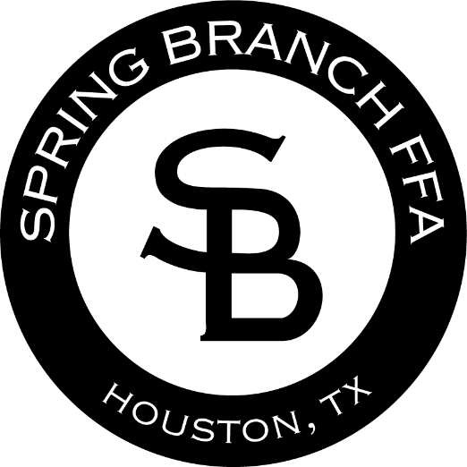

Test Date: _________________

Chapter 1: Career and Technical Education

Career and Technical Education
Career and Technical Education (CTE) bridges the gap between high school and postsecondary plans. CTE programs include career skills training that helps students become ready for college or work. CTE curriculum focuses students on academic, employability, and technical skills used in a specific occupation. Opportunities are available for students at the middle school, high school, and postsecondary levels.
There are 16 career clusters that CTE focuses on that contain over 79 sub-groupings called Career Pathways that are used by many school systems to develop curriculum to enhance the knowledge and skills required for a particular career field. See the 16 career clusters below:
16 Career Clusters:
- Agriculture, Food & Natural Resources
- Architecture & Construction
- Arts, Audio/Video Technology & Communications
- Business Management & Administration
- Education & Training
- Finance
- Government & Public Administration
- Health Science
- Hospitality & Tourism
- Human Services
- Information Technology
- Law, Public Safety, Corrections & Security
- Manufacturing
- Marketing
- Science, Technology, Engineering & Mathematics
- Transportation, Distribution & Logistics
CTE is for all students, whether they are planning to enter the workforce immediately after graduation or continuing their post-secondary education.
SBISD CTE will be aligned with the district’s T-2-4 plan that aims to expose and explore students’ academic and career interests and then provide them opportunities to experience their future options and prepare them to execute a postsecondary plan.
What does T-2-4 success look like in SBISD?
- Every SBISD graduate will attain a technical certificate, military training, or a two-year or four-year degree.
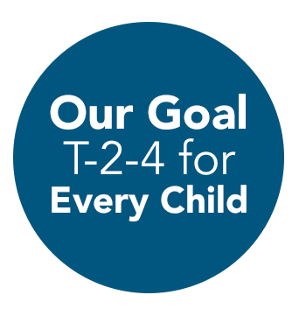
- SBISD will increase the number of students achieving T-2-4 from 44% to 72% by 2022.

Career and Technical Student Organizations (CTSOs)

Career and Technical Student Organizations (CTSOs) are key components to strong CTE programs. CTSOs integrate into CTE programs and courses and extend teaching and learning through innovative programs, business and community partnerships and leadership experiences at the school, state and national levels.
- CTSOs provide relevant, engaging programs that improve student achievement, reduce dropout rates and help students discover the wide range of career options available.
- CTSO programs, such as industry based competitive events and community service, provide students with the opportunity to develop 21st Century Skills focused on creativity, problem solving, teamwork and goal setting.
- CTSOs bring relevance to the classroom and prepare students to be college and career ready.

Making an Impact With more than 1.5 million student members combined, CTSOs have a definite impact on students’ overall college and career readiness
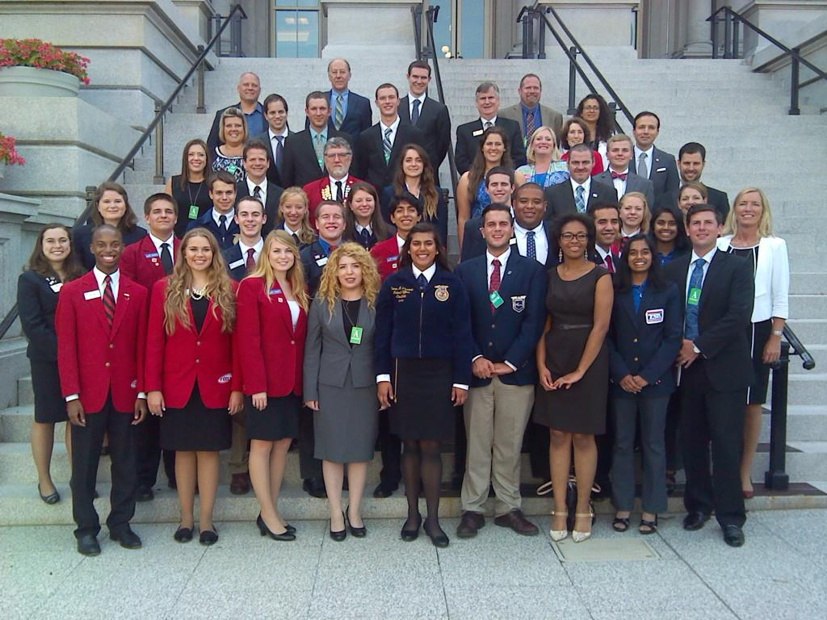

Students who participate in CTSOs demonstrate higher levels of academic engagement and motivation, civic engagement, career self-efficacy and employability skills than other students. | According to the National Research Center for Career and Technical Education, participating in leadership and professional development activities in a CTSO raises students’ educational aspirations. | Students who participate in school organizations in 10th grade have higher high school grade point average and are more likely to be enrolled in college at 21 than other students.

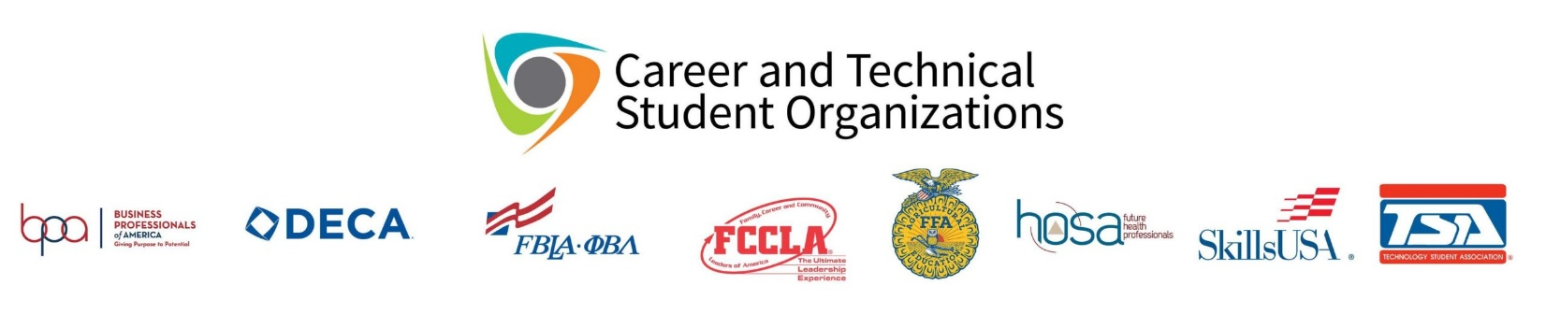
- The Business Professionals of America (BPA) is committed to developing the best possible career and technical education organization for students in the United States. The measure of our success will be the perception that alumni of Business Professionals of America are highly competent and skilled workforce professionals who enable business and industry to maintain the economic vitality and high quality of life associated with our celebrated United States of America.

- The Distributive Education Clubs of America (DECA) prepares emerging leaders and entrepreneurs for careers in marketing, finance, hospitality and management in high schools and colleges around the globe.

- The Future Business Leaders of America (FBLA) is an organization of business students and leaders designed to promote and develop competent, aggressive business leadership. The leadership program is constructed to strengthen the confidence of students in themselves and their work, create more interest in and understanding of American business enterprise system, and develop character that prepares students to be productive and patriotic citizens.

- The Family, Career and Community Leaders of America (FCCLA) is a nonprofit national career and technical student organization for young men and women in Family and Consumer Sciences education.

- The National FFA Organization (FFA) program is part of a three-part model of education that consists of classroom instruction, supervised agricultural experiences and the FFA. Classroom agricultural education is applied to hands-on learning opportunities. FFA makes a positive difference in the lives of students by developing their potential for premier leadership, personal growth, and career success through agricultural education.

- The purpose of the Health Occupations Students of America (HOSA) organization is to develop leadership and technical HOSA skill competencies. The mission of HOSA is to enhance the delivery of compassionate, quality health care by helping the student meet the needs of the health care community.

- The SkillsUSA is a partnership of students, teachers and industry representatives working together to ensure America has a skilled workforce. SkillsUSA helps each student to excel. SkillsUSA is a organization serving teachers and high school and college students who are preparing for careers in technical, skilled and service occupations, including health occupations and for further education.

- The Texas Association of Future Educators or TAFE (pronounced "taffy") is a co-curricular statewide, student organization created to allow young men and women an opportunity to explore the teaching profession.

- The Technology Student Association (TSA) is an organization of students who are engaged in science, technology, engineering, and mathematics (STEM). The TSA fosters personal growth, leadership, and opportunities in technology, innovation, design, and engineering.

The Guthrie Center

ABOUT GUTHRIE
The Harold D. Guthrie Center for Excellence serves high school students in the Spring Branch Independent School District in Houston, Texas. We are an elective campus for Spring Branch ISD high school students in Houston, Texas. Our technical, project-based, interactive classes emulate a work environment to prepare students as they transition to higher education or their chosen career.

The Guthrie Center Programs
3D Animation
Agricultural Sciences
Architectural Design
Commercial Photography
Computer/Info Tech
Cosmetology
Criminal Justice
Culinary Arts
Dental Assistant
Electrician Technician
Filmmaking
Graphic Design
Internships
Navy JROTC
Patient Care Tech
Pharmacy Tech

National Technical Honor Society:
NTHS is the acknowledged leader in the recognition of outstanding student achievement in career and technical education. Thousands of schools and colleges are affiliated with the Society. Member schools agree that NTHS encourages higher scholastic achievement, cultivates a desire for personal excellence, and helps top students find success in today's highly competitive workplace. Members must meet the following requirements to serve in the Guthrie NTHS.

- Must be currently enrolled in at least one Guthrie class
- Meet local and national membership standards
- Be nominated by their instructor(s)
- Be approved by the local administration
- Demonstrate scholastic achievement
- Show leadership, and good citizenship
- Student must be in grade 10, 11 or 12
- Must have an overall GPA of 3.5 on a 4 point scale
- Must have a overall GPA in CTE classes 3.5 on a 4 point scale

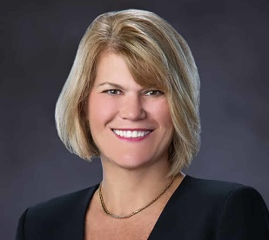
The Who’s Who of Spring Branch

Superintendent | Jennifer Blaine
CTE Director | Christina Rice-Imumwem
CTE Coordinator | Nicole Henneke
CTE Facilitators | Lori Vereen, Christine Walker & Melissa Caldwell
Guthrie Center Campus Principal | Joe Kolenda
Guthrie Center Campus Vice Principal | Jane Primrose
Guthrie Center Campus Counselor | Beverly Litton

School Board Members
President | _____________________________
Vice President | ____________________________
Secretary | _____________________________
Trustee | _____________________________
Trustee | _____________________________
Trustee | _____________________________
Trustee | _____________________________
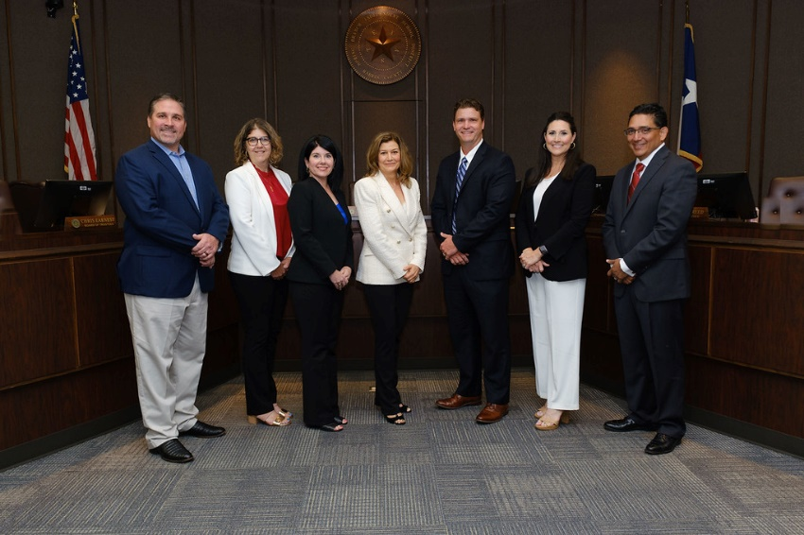

Chapter 2: The National FFA Organization
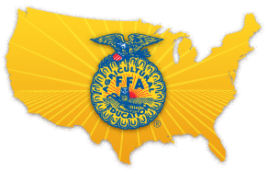
National FFA Organization
FFA is a dynamic youth organization that changes lives and prepares members for premier leadership, personal growth and career success through agricultural education. FFA develops members’ potential and helps them discover their talent through hands-on experiences, which give members the tools to achieve real-world success.

Members are future chemists, veterinarians, government officials,
entrepreneurs, bankers, international business leaders,
teachers and premier professionals in many career fields.

FFA is an CO-CURRICULAR student organization for those interested in agriculture and leadership. It is one of the three components of agricultural education.

The official name of the organization is the National FFA Organization. The letters “FFA” stand for Future Farmers of America. These letters are a part of our history and our heritage that will never change.

FFA Mission

FFA makes a positive difference in the lives of students by developing
their POTENTIAL for premier LEADERSHIP, personal GROWTH and
CAREER SUCCESS through agricultural education.

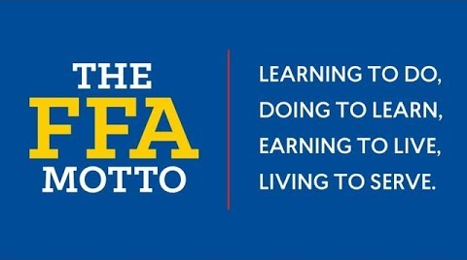

The Official FFA Colors
The Official FFA Motto

Co-curricular activities are those activities that are outside of but usually complementing the regular curriculum.
Extracurricular activities are defined as those school-based activities that are not tied to the curriculum.

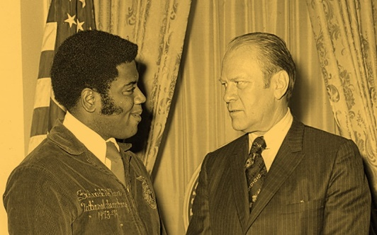
Important Dates

1917: Smith-Huges National Vocational Education Act
1928: Future Farmers of America is established
1929: Texas FFA becomes a charted state of National FFA
1930: Official FFA creed adopted by EM Tiffany and Official Dress adopted
1933: Blue Corduroy Jacket is adopted
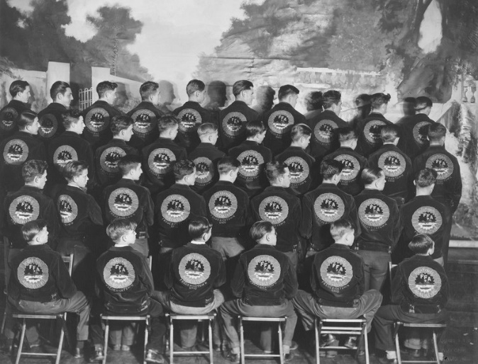
1965: New Farmers of America and FFA merge
1969: FFA Membership opens to females
1988: Names changes to the National FFA Organization

FFA Membership
National FFA
Texas FFA
Area (3)
District (Lake Houston)
Local Chapter (Spring Branch)
SBFFA Jr. FFA (7th & 8th graders)

Membership Numbers:

National FFA Texas FFA SBFFA
____________ FFA members ____________ FFA members ____________FFA members

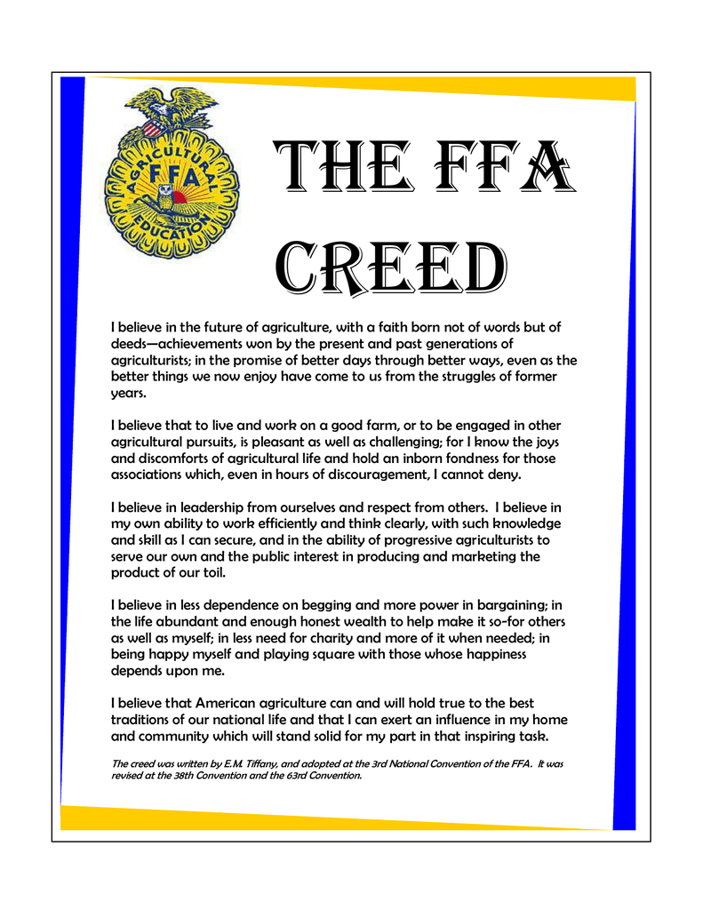

FFA Dues

National Dues…………………$7.00
Texas Dues……………………..$5.00
Area Dues……………………….$1.50
District Dues…………………..$1.00
SBFFA……………………………..$10.50

Total Annual Dues…..………$25.00

*Included in dues payment: FFA New Horizons Magazine subscription, SBFFA Chapter T-shirt, meals at meetings and banquets, & membership at all listed levels.

Chapter 3: Spring Branch FFA (SBFFA)

Spring Branch FFA
Spring Branch FFA and The Guthrie High School Ag Science classes go hand in hand. You cannot have one without the other. Spring Branch FFA is a co-curricular club and extension of the Ag Science Classes at The Guthrie Center. Any student enrolled in an Ag Science class is eligible to be a FFA member and to participate in the many opportunities that are available to them.
We follow the Three Circle Model of FFA: Ag Science Class/Instruction, FFA and SAE's so students can accomplish a well-rounded Agricultural Education in High School.
3 Ring Model
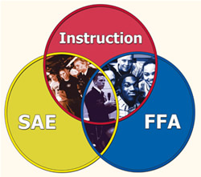
Spring Branch FFA 2023 – 2024 Officer Team
___________________________ President
___________________________ Vice President
___________________________ Secretary
___________________________ Treasurer
___________________________ Reporter
___________________________ Sentinel
___________________________ Student Advisor
___________________________ Parliamentarian
___________________________ Chaplin
___________________________ Historian
SBFFA Agricultural Science Teachers
Kathryn Corona | Michael McManners | Nicole Nosrat | Peyton Fisher
Small Animal Mgt/Equine Science  Veterinary Medicine  Advanced Animal Science | Wildlife & Ecology Mgt.  Livestock Production w/lab | Wildlife & Ecology Mgt.  Floral Design w/lab | Principles of Agriculture  Small Animal Mgt/Equine Science
Poultry  Rabbits | Cattle | Swine | Lambs  Goats
kathryn.corona@springbranchisd.com | michael.mcmanners@springbranchisd.com | nicole.nosrat@springbranchisd.com | peyton.fisher@springbranchisd.com

How to Join Spring Branch FFA

High School Membership Joining Process
- Must be enrolled in a High School Ag Science Class
  - 1st year members must be enrolled in the fall semester (preferrably full year)
  - 2nd year + members must be enrolled in a minimum of 1 semester each yeary of membership
- Pay Annual FFA Membership dues ($25)
- Complete and Submit FFA Membership Google Form by October each year
You have to be in an AG class to be in FFA! You do not have to be in FFA to be in an AG class!

Junior FFA Membership Joining Process
- Be in 7th or 8th grade in a SBISD School
or
- Be in 3rd-6th grade in a SBISD School with a sibling that has been an SBFFA member
of
- Be in 3rd-6th grade in a SBISD School with a parent that works in the district.
- Pay Annual FFA Membership dues ($25)
- Complete and Submit FFA Membership Google Form by October each year

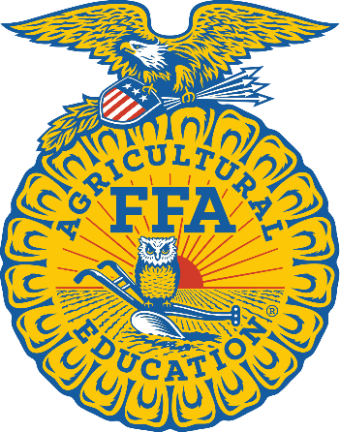
What classes can I take to join SBFFA?

What does joining FFA do for me?
AG Classes in SBISD
SBISD Pathways
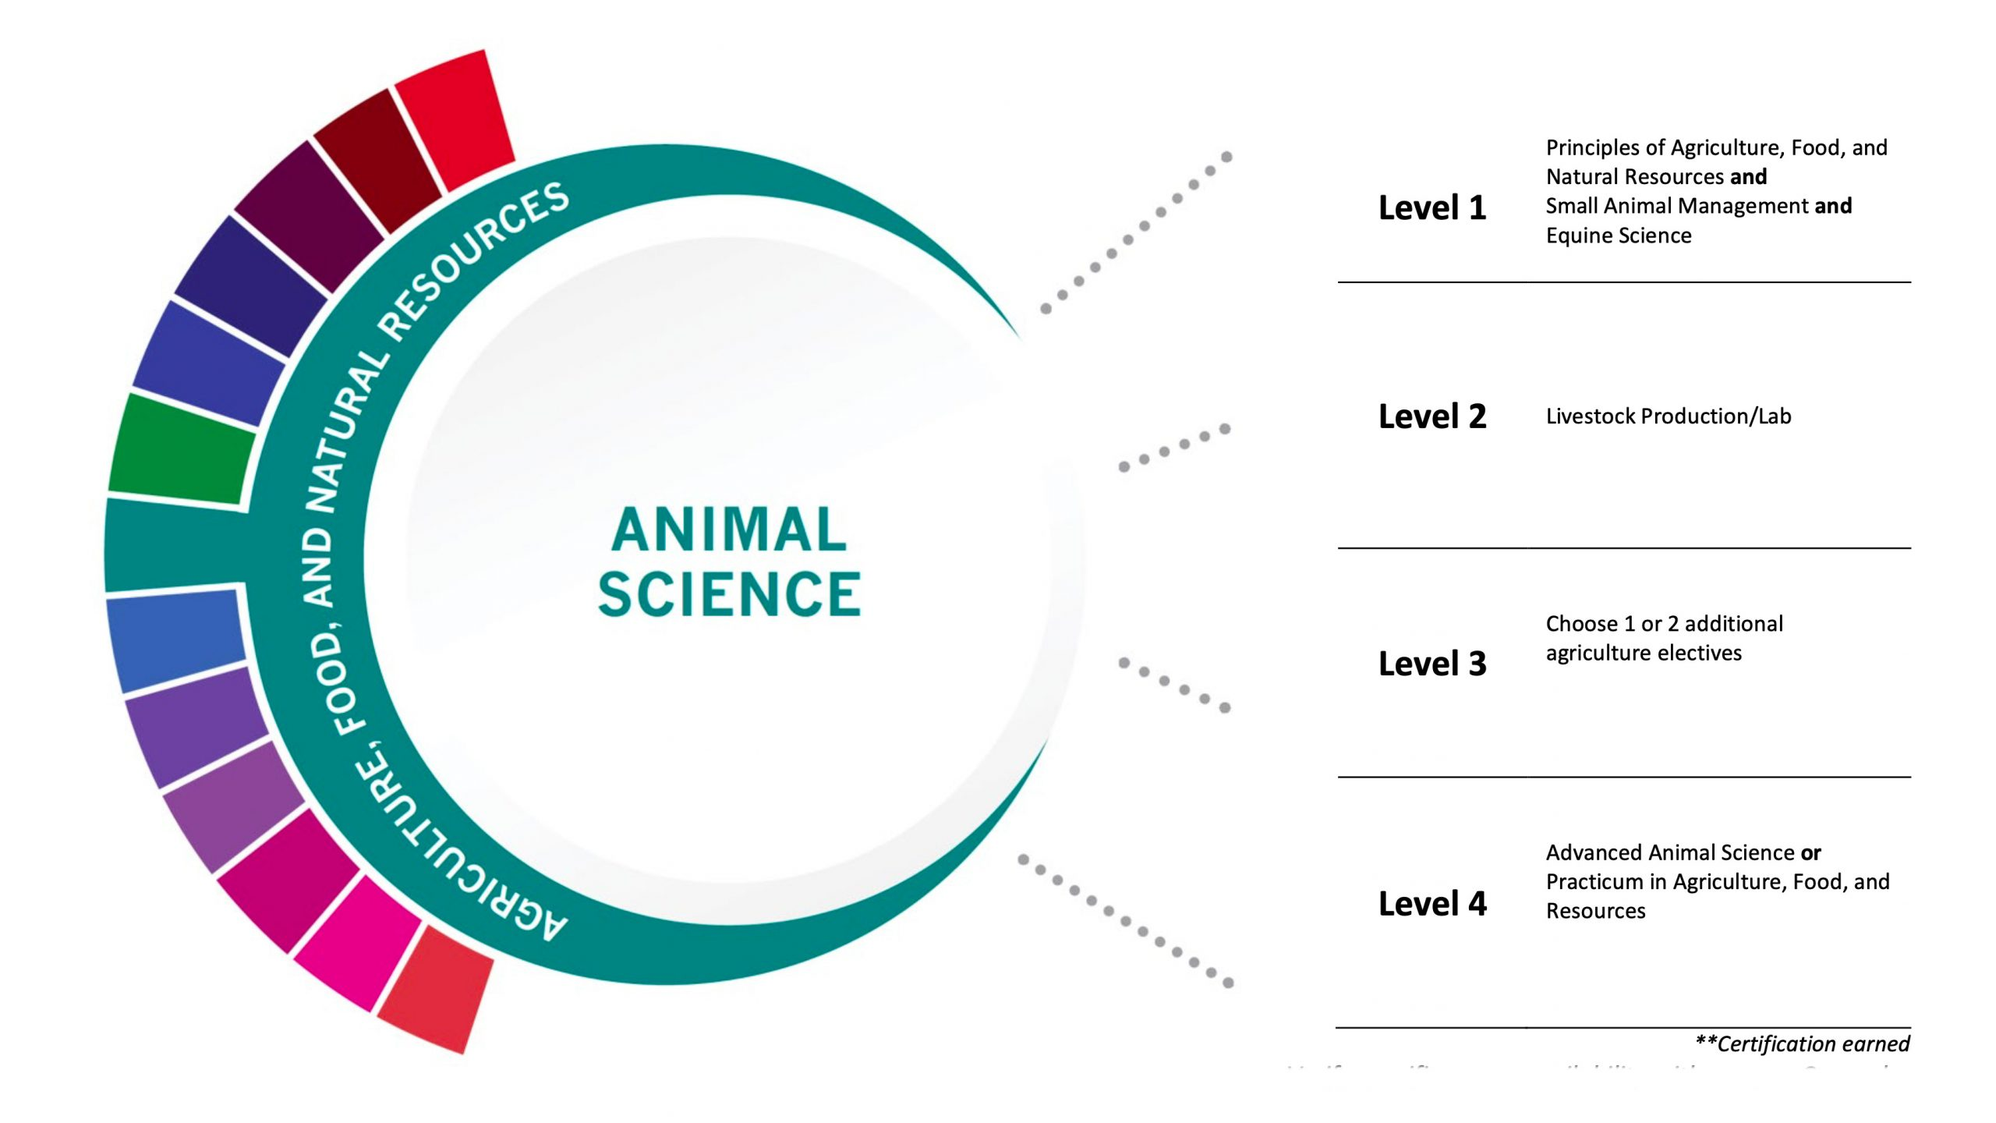
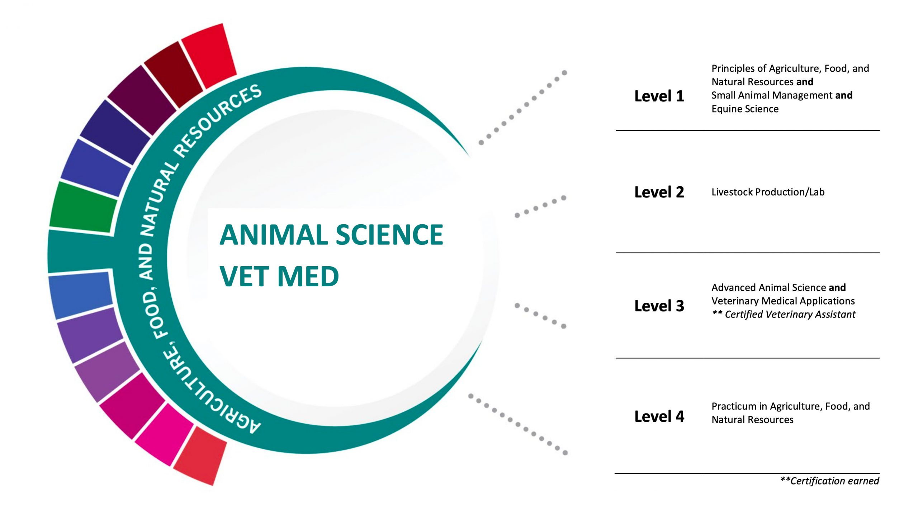
Endorsement: Business and Industry

PRINCIPLES OF AGRICULTURE, FOOD AND NATURAL RESOURCES (AFNR)
Don’t think agriculture affects you? Get ready for this eye-opening class! Learn how food, clothing, shelter, transportation, medicine, and modern-day conveniences rely on agricultural products. Students will also explore our CTSO, the FFA Organization. 9th-10th Grade
SMALL ANIMAL MANAGEMENT AND EQUINE SCIENCE
In Small Animal Management, the first of these concurrent classes, you’ll learn what a valuable role dogs, cats, hamsters, birds, and reptiles play in our society. Develop knowledge and skills pertaining to the selection, nutrition, grooming, reproduction, health, and management of small animals. Live animals are used in classroom demonstrations. Equine Science is the second class and you will be exposed to the science of horses and technology principles that include genetics, anatomy, physiology/nutrition, diseases, pests, and management practices. Topics also include an introduction to the equine industry, various breeds, conformation, selection, care and management, soundness, health, feeding, farrier observation, restraints, general vaccinations, and overall managerial duties. 10th-12th Grade
Recommended Prerequisite: Principles of AFNR
Technical Certification: Equine Management and Evaluation Certification

LIVESTOCK PRODUCTION w/Lab
Gain insight and information about the animals that feed our world. This course will provide you with an introduction to livestock production including anatomy, nutrition, health care, and information specific to the species. If you are interested in livestock judging this is for you. 10th-12 Grade
Recommended Prerequisite: Principles of AFNR
Offered as a 2 credit course (with lab)
Technical Certification: Elanco Fundamentals of Animal Science

FLORAL DESIGN W/Lab - A CTE COURSE FOR FINE ARTS CREDIT
Let loose your creative side as this hands-on course takes you through step-by-step instructions of arranging flowers and interior plant designs. Leave this class with the skill to arrange flowers for yourself or for others and get to take home your designs. 10th-12th Grade
Recommended Prerequisite: Principles of AFNR
Offered as a 2 credit course (with lab)
Technical Certification: Texas State Floral Association Level 1 Floral Certification

WILDLIFE, FISHERIES, & ECOLOGY MANAGEMENT
This course is designed for students who love the great outdoors. Learn how to identify, manage, and conserve wildlife and its ecology. 10th-12th Grade
Recommended Prerequisite: Principles of AFNR
Technical Certification: Texas Hunters Education Certification

ADVANCED ANIMAL SCIENCE - A CTE COURSE FOR SCIENCE CREDIT.
Meet a class that will take you farther. This course is designed for students who want to deepen their knowledge of the livestock industry. In-depth studies include animal industry, anatomy & physiology, and livestock husbandry. Offered spring semester only. 11th-12th Grade
Core Prerequisites: Biology & Chemistry/IPC, Algebra & Geometry
AFNR Prerequisites: Small Animal Management and Veterinary Medical Applications

VETERINARY MEDICAL APPLICATIONS
Explore the basics of the veterinary medical profession and know what goes on behind the scenes of a vet clinic. You will gain skills that technicians need to know, like handling a wide variety of animals, assisting clients, office management, and legal issues. Learn common ailments and treatments as well as emergency care techniques. Classroom demonstrations will use live animals. 11th-12th Grade
Prerequisite: Minimum C average in Livestock Production or Small Animal Mgt/Equine Science.
Technical Certification: Elanco Veterinary Medical Applications Certification

AGRICULTURE PRACTICUM
Practicum experiences can occur in a variety of ways including employment, independent study, internships, assistantships, mentorships, or laboratories. You will use what you know to acquire industry-expected workplace skills, career opportunities, entry requirements, and industry expectations. 11th-12th Grade

Opportunities In FFA
Joining FFA allows for students to develop their potential for Premier Leadership, Personal Growth and Career Success through diverse opportunities. Below are the multiple opportunities available to students once they join FFA!
Leadership Opportunities
Student Officer Teams: The National FFA Organization is the largest student led organization in the nation. Being student led means that a group of members are elected at the different levels to serve as the official officer team. This team of members take on a major role of leadership by leading by example and encouraging members to participate in all aspects of FFA while planning the chapter program of studies (POA) and executing the POA.
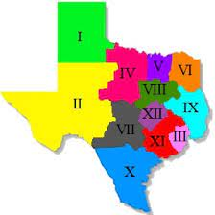
National FFA Officer Team = 6 Members (1 from each of the 6 regions)
Texas FFA Officer Team = 12 members (1 from each of the 10 Texas FFA Areas)
Area III Officer Team = 12 members (2 from each of the 5 districts)
Lake Houston District Team = 7 members (7 chosen from chapters in that district)
SBFFA Officer Team = 7-10 members (7-10 chosen from SBFFA members)
*Duties of the chapter officers are plan meetings, plan the chapter program of activities, attend conventions, act as voting delegates for official FFA business, properly conduct and run monthly chapter meetings using parliamentary procedure and encourage participation among the members.
*Officers are elected to serve a full year term of service at every level. You are held to higher standards and greater expectations as leaders of the organization.

SBFFA Ambassadors: A unique SBFFA opportunity for members who want to educate those outside of the current SBFFA Membership. This team of 5 11th-12th grade SBFFA members will travel to middle schools, talk with counselors and be an active participant in recruiting SBFFA members and educating the public about our program.

Ford Leadership Scholars: 10 students from chapters across the state are chosen in May to serve as a FLS for the year. These 10 students will attend a weeklong training during the summer to equip students to go back to their communities to develop substantial and sustainable community service capstone projects. The purpose of the program is to:
1) Identify students who exhibit high levels of leadership at the chapter level.
2) Engage these identified students in a leadership development program created to enhance those qualities of leadership.
3) Recognize the Scholars to build a remarkable legacy for the future of our state and nation.

Conventions/Conferences: Student officers, competition winners and award recipients often have the opportunity to travel with us to camps and conventions throughout the school year and summer. These camps, conventions and conferences offer students the ability to further develop their leadership skills while also networking and exploring career options.
Competition Opportunities

Competition Teams
Leadership Development Events (LDEs): Fall contests that focus on creating situations for members to demonstrate their abilities in public speaking, decision making, communication and their knowledge of agriculture and the FFA organization. Team and individual events are used to reinforce what is taught in agricultural science classrooms.
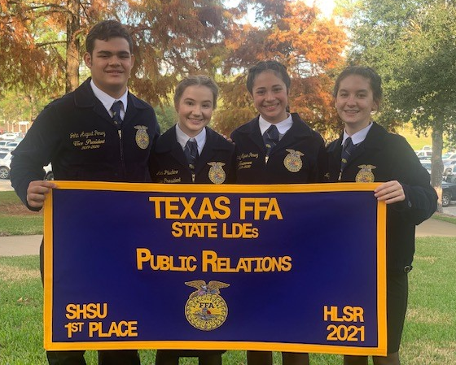
Agricultural Advocacy
Public Relations
Agricultural Issues Forum
Agricultural Skill Demonstration (GH)
Chapter Agricultural Quiz (GH)
Chapter Conducting (GH)
Creed Speaking (GH)
Job Interview
FFA Broadcasting
https://www.texasffa.org/lde

Career Development Events (CDEs): Spring contests that build on what is learned in agricultural classes and encourage members to put their knowledge into practice. These events are designed to help a member prepare for a career in agriculture by testing and challenging the student's technical, leadership, interpersonal and teamwork skills as well as their knowledge of the subject matter. CDEs answer the question, "When will I use this knowledge in the real world?"

Ag Sales
Entomology
Farm and Agribusiness Management
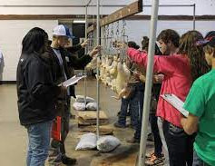
Horse
Wool

Marketing Plan
Meats
Poultry
Veterinary Science
Nursery Landscape

And many more!
https://www.texasffa.org/cde

Speaking Development Events (SDEs): Spring contests that are designed to develop the ability of all FFA members to express themselves on a given agricultural subject. Students are encouraged to develop their communication skills and learn to formulate their remarks for presentation in a variety of situations.
Jr Prepared Extemporaneous Soil Stewardship Sr Prepared
https://www.texasffa.org/speaking-events

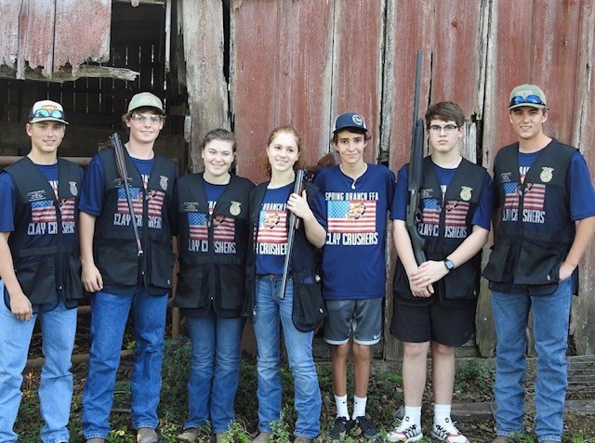
Shooting Sports: SBFFA Clay Crushers is a competition team within FFA that allows our members a chance to participate in the competitive environment of shooting sports. This portion of SBFFA is open to high school SBFFA members whether they are first time shooters or have been shooting for years. Pay your annual $100 dues, attend practices and tournaments across Texas with the opportunity to shoot at major stock shows and state shoot in the summer. Team members must meet the required courses or certifications in order to participate.

Agriscience Fair: Students use the scientific process as they reinforce skills and principles, they have learned in agriscience courses. They conduct research projects and prepare a scientific report and display for judging at the state level.
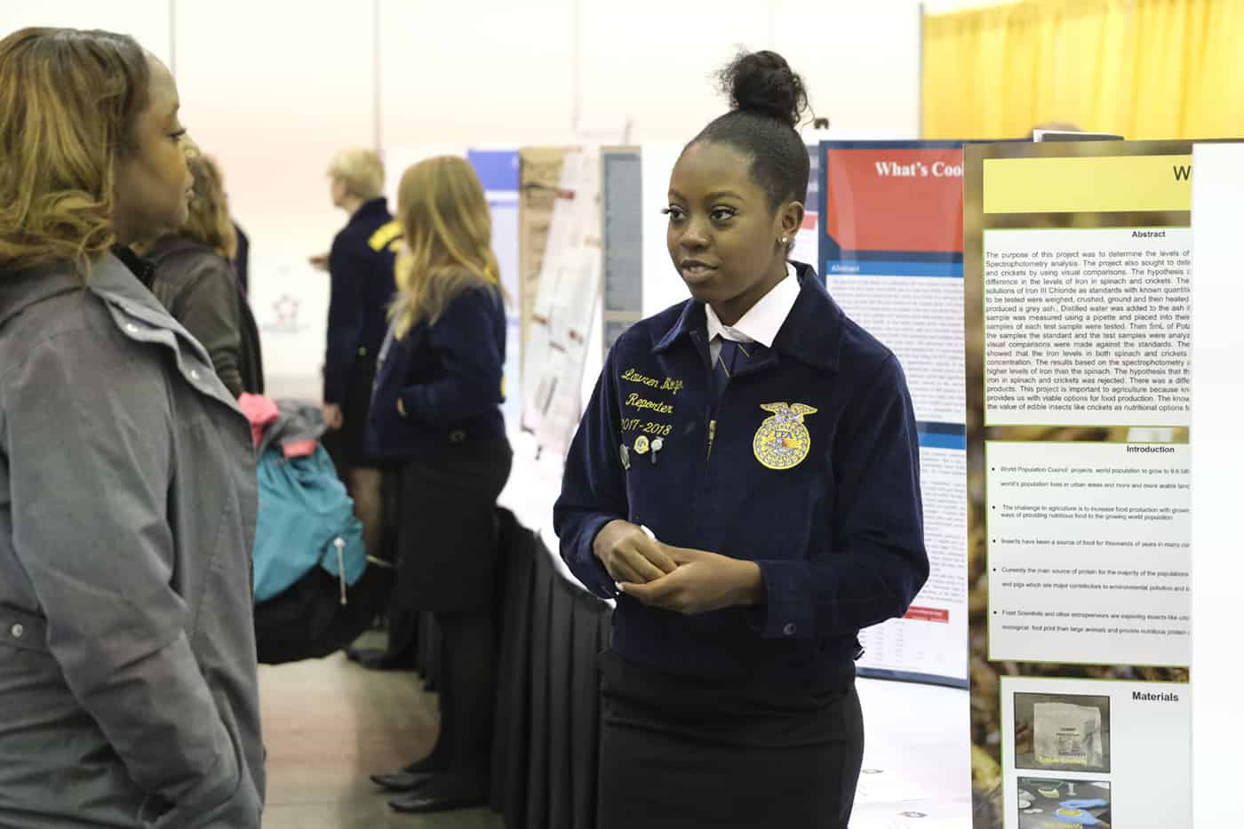
State winners in each category in divisions 3-6 are awarded $1,000 scholarship. State winners in each category in divisions 1-2 are awarded $250 scholarship. All state winners will advance to the National FFA Summer Judging Process and are eligible to compete at the National FFA Agriscience Fair held in conjunction with National FFA Convention.
- Division 1 – individual member in grades 7 and 8
- Division 2 – team of two members in grades 7 and 8
- Division 3 – individual member in grades 9 and 10
- Division 4 – team of two members in grades 9 and 10
- Division 5 – individual member in grades 11 and 12
- Division 6 – team of two members in grades 11 and 12

Supervised Agricultural Experiences (SAEs): This program involves practical agricultural activities performed by students outside of scheduled classroom and laboratory time. SAEs provide a method in agricultural education for students to receive real-world career experiences in an area of agriculture that they are most interested in. SAEs are a required element of being enrolled in an AG Science Course.
Types of SAEs
FOUNDATIONAL SAE
- Foundational SAEs support a student's career interest. Projects and experiential learning activities for all types of SAEs will develop the student in each of these five Foundational component areas:
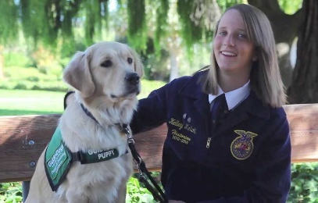
  - Career Exploration
  - Employability Skills & College Readiness
  - Personal Financial Management
  - Workplace Safety
  - Agricultural Literacy Immersion SAEs (traditional SAEs) are developed here.
IMMERSION SAE
- Immersion SAEs are an extension of the Agricultural Literacy component of the Foundational SAE and will contribute to a student's growth in all of the Foundational components in an authentic, contextualized manner. The five Immersion SAE categories build upon the Foundational SAE components in a real-world application.
  - Placement/Internship SAE: The student is in an employment setting (paid or unpaid). This experience must provide opportunity for development and advancement of skills and abilities aligned to the AFNR Technical Standards and Career Ready Practices.
  - Ownership/Entrepreneurship SAE: The student operates an individual business which provides goods and/or services to the marketplace in the ownership aspect. The student transitions to an entrepreneurship SAE once the ownership SAE is enhanced to contain or meet additional criteria.*Raising and selling animals of any species is production agriculture and does not fit the agribusiness category.*
  - Research: Experimental, Analysis or Invention SAE: The student will be involved in an investigation of materials, processes and information to establish new knowledge or the validation of previous research.
  - School-Based Enterprise SAE: A group of two or more students will work cooperatively outside of normal class time to create a business enterprise that provides goods and services. They operate their enterprise from the school campus utilizing facilities, equipment and other resources provided by the AFNR program or the school.
  - Service Learning SAE: Conducted by one or more students in which they plan, conduct and evaluate a project designed to provide a service to a school, public entity or the community. It must provide benefits to another organization, group or individuals other than the FFA chapter.
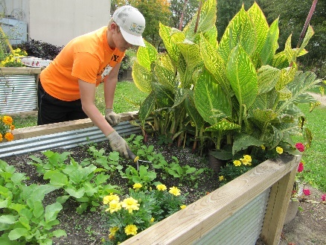

Awards and Recognitions
Degrees of Membership: Each degree of active membership requires commitment and a lot of hard work, but you don’t have to be a gifted student or live on a large farm or ranch to reach your goals. The FFA degree system is organized so that all FFA members, no matter where you are from, have an equal chance of obtaining each degree of membership. However, you must show progress in your Supervised Agricultural Experience (SAE) program to have a realistic chance at attaining this goal.
- Greenhand Degree: FFA members enrolled in their first year of high school credit agricultural science, that have satisfactory plans for a supervised agricultural experience (SAE) program and that have demonstrated their understanding of the history and purpose of the FFA may apply for their Greenhand Degree. This degree of active membership is awarded at the chapter level.

- Chapter Degree: Members must have their Greenhand Degree, be enrolled in an agricultural science class, have completed at least two semesters in agricultural science at or above the ninth grade level, have in operation an approved SAE program, demonstrate leadership skills and be actively involved in the activities of the local FFA chapter. This degree of active membership is awarded at the chapter level.

- State Degree (Lonestar): This is the highest degree of membership the State FFA Association can award. FFA members may apply to receive the Lone Star Degree only after they have received the Chapter degree, and must have been an active FFA member for at least two years, complete at least four semesters of agricultural science at or above the ninth grade level, maintain a supervised agricultural experience (SAE) program, invest significant time and money in their SAE, demonstrate their leadership skills and show a commitment to the FFA through involvement at the chapter level and above. This degree of active membership is awarded at the state level during the Texas FFA convention.

- American Degree: This degree of active membership is awarded by the National FFA Organization and is the highest level of active membership which can be achieved within the FFA. This final step encourages members to grow and achieve personally toward establishing yourself in an agricultural career. Members may apply for their American degree only if they have received the State FFA Degree, have graduated from high school at least twelve months prior to the national convention and meet the very high standards for the degree. These requirements include an excellent record of involvement within the FFA, operation and maintenance of records to substantiate an outstanding supervised agricultural experience program through which a member has exhibited comprehensive planning, managerial and financial expertise, have earned and productively invested a specific amount of both time and money.

Proficiency Awards: This program encourages members to set personal goals and learn practical skills within their SAE project. The program provides recognition to FFA members at the local, state and national levels for exceptional accomplishments and excellence in their Supervised Agricultural Experience (SAE) program. There are 51 proficiency award areas that individuals can apply for, ranging from Agricultural Communications to Wildlife Production and Management.
- Proficiency awards will be judged by the following criteria:
  - Skills and competencies learned that relate to an agricultural career field.
  - Financial achievements, including growth in scope.
  - Personal growth and development through FFA activities.
  - Evidence of student accomplishments based on available resources and opportunities.
  - Communication skills as demonstrated in the written portions of applications and clear, concise answers given during interviews.

Star Awards: An outstanding member at each degree level can be awarded the Star Award based on an exceptional overall Supervised Agricultural Experience (SAE) program and FFA involvement. There are four divisions of the star award within each degree level, except the Discovery Degree. These divisions reflect the diversification of supervised agricultural experience programs and student populations in the state.
- Star Award Divisions:
  - Star in Production: Outstanding achievement in an entrepreneurial production agriculture SAE and active participation in the FFA.
  - Star in Agri-Business: Outstanding achievement in an entrepreneurial agribusiness SAE that focus on agricultural sales, service or other entrepreneurial endeavors along with active participation in the FFA (All horticultural enterprises fall under agribusiness even if they are production oriented).
  - Star in Agricultural Placement: Outstanding achievement in an employment SAE, these can include work-based learning, along with an active participation in the FFA.
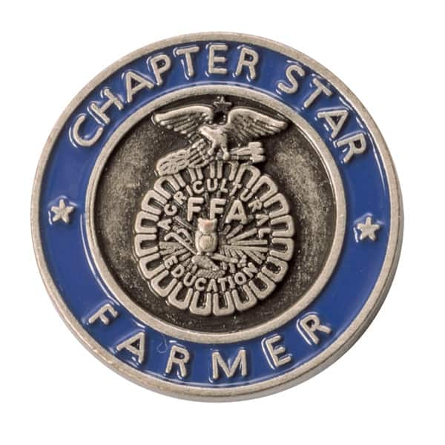
  - Star in Agri-Science: Outstanding achievement in an SAE where the student’s SAE programs are aimed at developing higher order scientific knowledge and skills along with active participation in the FFA.

FFA Scholarships
National FFA Scholarships: Through the National FFA Foundation, businesses and individuals support scholarships that are awarded to students with a wide variety of higher education plans and career goals. Whether you are planning on attending a specialized training program or seeking a four-year degree, the National FFA Scholarship Program has opportunities for all.
- Scholastic record is important but not always the determining factor in scholarship selection. Each applicant received an evaluative score for FFA activities and work experience; leadership and service activities; as well as academic record. Financial need and other specialized criteria are considered on selected scholarships as required by the sponsor. 976 FFA members in the US received a national FFA scholarship ranging from $500-$10,000 with over $2 million to be handed out each year. The average GPA of recipients in 2021 was 3.77 on a 4.0 scale. The application process for these scholarships is from November 1st to Mid-January.

Texas FFA Scholarships: The Texas FFA Association is proud to award more than $1 million in scholarships annually to deserving FFA members. Scholarships recognize members' academic accomplishments as well as participation in FFA programs and activities. Texas FFA Scholarship recipients are recognized for their achievements on stage at the state convention.
- Texas FFA will award more than 140 scholarships to outstanding graduating seniors through its academic scholarship program. These scholarships are awarded based on academic and FFA achievements as well as the member's performance in an interview process. STUDENTS MUST TAKE AND SCORE A MINIMUM OF 1000 ON THE SAT OR 19 ON THE ACT TO BE ELIGIBLE TO APPLY. Applications for this scholarship typically open in Mid-January and close in April.

SBFFA Scholarships: Our Alumni parent support group gives out $10,000 to 5 deserving seniors each year. Members earn these scholarships through their involvement with SBFFA and National FFA through all 4 years of high school involvement and a short essay.
- Other: __________________________________________________________________________________________________
_________________________________________________________________________________________________________
_________________________________________________________________________________________________________

SBFFA Show and Sale
SBFFA members get the unique opportunity to participate in a program that provides opportunities. Whether that is learning and immersing yourself in production agriculture or setting yourself up financially for life after high school. Our SBFFA Livestock Show and Live Auction allows for many possibilities for students. With our 17-acre ag farm in the heart of Spring Branch, students have the opportunity to raise livestock animals for exhibition and potential profit through our live auction sale in February. If animals are too big of a commitment, then other non-livestock projects are also possible with the opportunity for financial gain. This show and sale is hosted by our parent support group known as the SBFFA Alumni.

Livestock Animals
Species | Arrival Date | Initial Cost Estimate | Time Commitment | Other Costs
Steers | Late May | $2,000+ | 9 Months+ | Feed, bedding & supplies
Heifers | March-June | $2,500+ | 1-2 Year Project | Feed, supplies, breeding & major show entry fees
Pigs | October | $500 | 4 Months | Shavings, feed, supplies
Lambs | October | $600 | 4 Months | Feed & Supplies
Goats | October | $600 | 4 Months | Feed & Supplies
Rabbits | January | $350 (pen of 5-6) | 1 Month | Feed & Supplies
Turkeys | Early November | $200 (pen of 5) | 3 Months | Feed & Supplies
Broilers | Late December | $200 (pen of 25) | 1 ½ Months | Feed & Supplies

- The above species are shown at the SBFFA Show and Sale in February. Animals can also be raised at the farm to go show at Major stock shows like HLSR and San Antonio.
- Steers/Heifers/Pigs/Lambs/Goats have to be raised at the farm
- Broilers/Turkeys/Rabbits can be raised at the farm or at home with proper set up.
- All animals are expected to be fed and cared for twice a day.

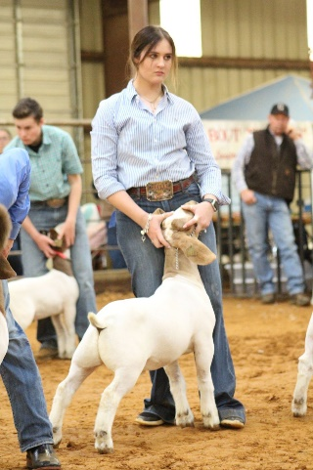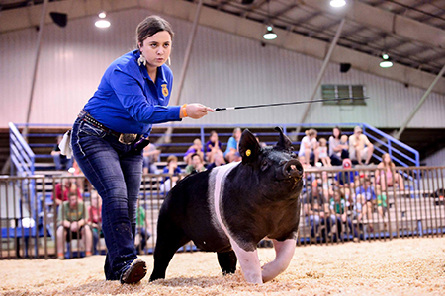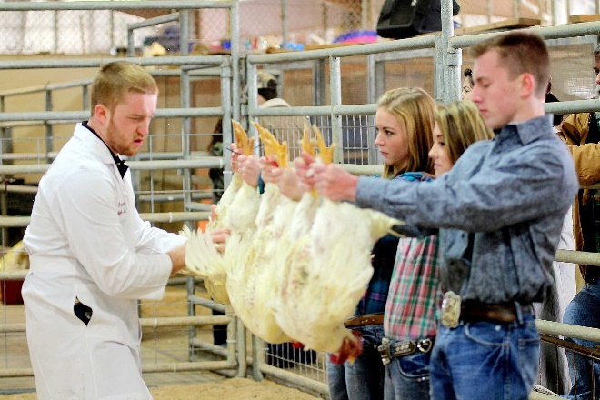
Mandatory Events for Show and Sale:
__________________________________ _________________________________ ___________________________________
__________________________________ _________________________________ ___________________________________
__________________________________ _________________________________ ___________________________________
Non-Livestock
$10 entry fee and can enter up to 10 entries in separate classes within divisions.
- Ag-Mechanics
  - Metal Working
  - Wood Working
  - Other
  - Grand and Reserve Champion sold in live auction. Other entries eligible for silent auction.
- Horticulture
  - Hanging Arrangements
  - Terrariums
  - Container Gardens
  - Cut Floral Arrangements
  - Grand and Reserve Champion sold in live auction. Other entries eligible for silent auction.
- Creative Arts
  - 2-D Art
  - Decorative & Functional Crafts
  - Ceramics & Sculpture
  - Textile Design & 3-D
  - Grand and Reserve Champion sold in live auction. Other entries eligible for silent auction.
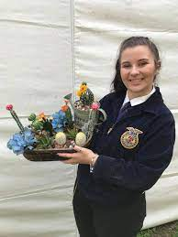
- Food
  - Cookies
  - Cakes
  - Pies
  - Canning
  - Candy
  - Bread
  - Grand and Reserve Champion sold in live auction. Other entries eligible for silent auction.
- Photography
  - Color Photo
  - Black and White Photo
  - Grand Champion wins $500 and Reserve Champion wins $250, 3rd place $100, 4th place $50
- Agriscience Fair
  - Individual or team of 2 for each of the following categories
    - Animal systems, Environmental Services, Food Products and Processing, Plant Systems, Power and Technical Systems, & Social Science.
  - Grand Champion wins $500, Reserve Champion wins $250, 3rd place wins $100, & 4th place $50
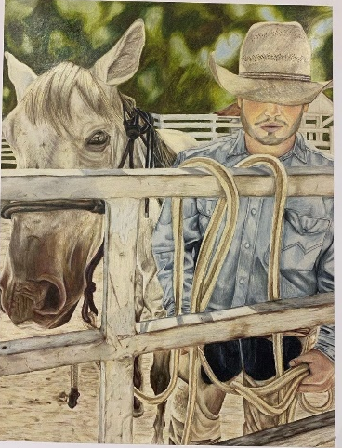

Participation in both livestock and non-livestock has requirements and mandatory events tied to it. Potential interested students are encouraged to come out to Brunch at the Barn in August to learn more and sign up to be an FFA member to get on our email list. More information about show and sale can also be found on our website!

http://www.springbranch.ffanow.org/

FAQ Regarding Show and Sale
Do I have to be an FFA member to show?
- Yes. either a Jr FFA member or High School FFA member.
Do I have to be in an AG class to show?
- If in Jr FFA, no. If in 9th-12th grade, you are required to be enrolled in 1 ag class a year.
I do not have the funds to raise an animal, what help is there?
- We have supporters that are willing to sponsor or loan money to the start up of the cost of an animal. Encourage students to talk with the ASTs about this avenue.
I do not have transportation to get me to the barn twice a day, can I still participate?
- Animals at the barn are required to be tended to twice a day before school and after school. Morning feedings are from 5:30-7:30 AM and afternoon feeding are from 3:30-10:00 PM each weekday and weekends are from 5:30AM-10:00PM. It is encouraged to carpool with other members from your same school.
________________________________________________________________________________________________________________________________________________________________________________________________________________________________
What happens to my animal in February?
- All animals with the exception of breeding heifers are terminal animals and will be sold for market and food production.
Who buys the animals?
- Local businesses, friends and family attend the auction to purchase student projects. It is encouraged to bring your own buyer in but the Alumni does a good job of inviting buyers to purchase all projects.
I do not want to raise an animal, can I still participate?
- FFA as shown above has many opportunities outside of the show world. However, a chance to still win money without raising an animal is through the non-livestock portion of show and sale.
Are there limits on what I can raise?
- There are limits on number of animals that can be raised and shown. With the exception of cattle, species may have no more than 2 animals per barn with a max of 4 animal projects. Jr. FFA is not limited to a certain species but pen availability is given priority to high school members.
Does my parent have to be involved?
- If you participate in show and sale, at least 1 parent or guardian is required to join the Alumni. They have monthly meetings that are highly beneficial to attend.
What happens if my animal gets sick or dies?
- Students assume all financial risks of raising an animal. This includes if the animal dies or gets sick and a vet has to be called out. The ASTs can help with very basic diagnosis and medication and will always encourage you to call a vet for major or undiagnosable issues. There are death clauses in place for different species but after certain times, if an animal dies, the student loses out on the opportunity to raise their animal.
Who pays for feed and supplies?
- All supplies and feed needed to raise your animal are paid for by the student.
Alumni Association
FFA relies on its alumni to garner support for FFA from their local communities, raise funds for chapter activities and scholarships, assist at FFA leadership camps and conferences, and more. You don't have to be a former FFA member to support FFA, agricultural education and the future of agriculture.

FFA Alumni helps get more support from the community for agriculture programs and to give agriculture science teachers more time and freedom to do what they do best - teach kids. Through their commitment to FFA and agricultural education, FFA Alumni help guide the students in their communities down the path to success. They are also responsible for hosting the annual Show and Sale. If a student raises a livestock animal, at least 1 parent is required to join the alumni. There are no mandatory dues upon joining but encouraged donations.

To learn more, go here: https://www.sbffaalumni.com/home

Our SBFFA Alumni has many parents and connections willing to help sponsor students projects, official dress and other financial obligations. Please encourage students to reach out to the ASTs if ever in need!

Executive Board: The E-Board is the group of volunteers that are elected to serve as the leaders of the Alumni parent group. Major show decisions and financial spending
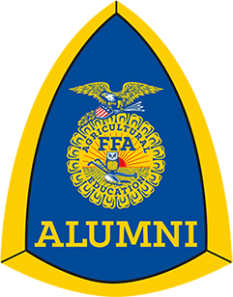
President | _____________________ | sbffa.alumni.president@gmail.com
President Elect | _____________________ | sbffa.pres.elect@gmail.com
Vice President | _____________________ | sbffa.vp@gmail.com
Treasurer | _____________________ | sbffa.treasurer@gmail.com
Treasurer Elect | _____________________ | sbffa.treas.elect@gmail.com
Secretary | _____________________ | sbffa.secretary@gmail.com
Show Works | _____________________ | sbffa.show@gmail.com
Show Works Elect | _____________________ | sbffa.show.elect@gmail.com

Chapter 4: Agriculture Careers
AG After High School
Currently there are over 300 million people in the U.S. that need to put food on their tables. Over the next 35 years the world’s population will increase to near 9.6 billion, making the need for agriculture more significant than ever. We need to work together to increase agriculture production by 70%, therefore agriculture jobs across the world will be valuable for years to come. With the growing threat of climate change, the agriculture industry is in need of major changes to protect the future of our planet. The demand for motivated, innovative individuals that want to be part of the solution is greater than ever. By choosing a career in agriculture, you can contribute to solving this global crisis and make a huge difference.
Animal Science Degree Careers:
- Veterinarian
- Vet Technician or assistant
- Animal Nutrition Specialist
- Animal Geneticist
- Animal Physical Therapist
- Animal Trainer
- Meat Inspector
Plant Science Degree Careers:
- Entomologist
- Golf Course Turf Grass Manager
- Florist
- Hydroponics Producer
- Irrigation Specialist
- Landscape Designer
- Produce Inspector
AG Education Degree Careers:
- AG Science Teacher (Secondary)
- Country Extension Agent
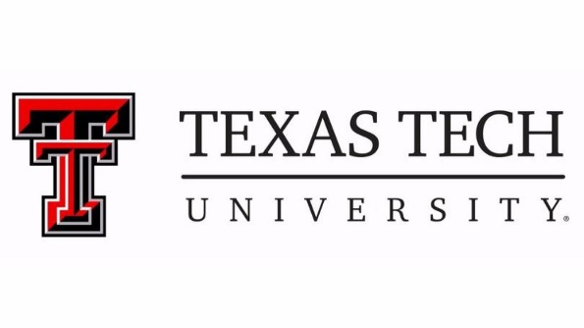
- College Professor (Post-Secondary)
AG Business Degree Careers:
- Accountant
- AG Lawyer
- AG Loan Officer
- AG Lobbyist
- Graphic Designer
Learn about more career opportunities & encourage students to visit this page to learn about careers in AG:
https://agexplorer.ffa.org/

Notes:

Spring Branch FFA
Feeding Minds, Building Leaders

2023 - 2024
SBFFA Ambassador Handbook
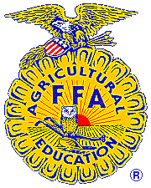

Becoming a Chapter FFA Ambassador is a challenging process, yet a very rewarding opportunity. Through this process, you will grow as a person and advance in leadership development and career preparation. Congratulations on deciding to run for ambassador!

“A good leader inspires people to have confidence in the leader; a great leader inspires people to have confidence in themselves.” Author unknown

SBFFA Ambassador Handbook
Please review the enclosed Chapter Ambassador Handbook. It clarifies the expectations of being an SBFFA Ambassador including required activities.

If you have any questions about any part of the process or the expectations of being an Ambassador, please contact your Advisor.

Selection Process
- Turn in a typed completed application by March 19th @ 4PM
  - Can be found on the Springbranch.ffanow.org website under the chapter tab
  - Turn in a signed Handbook Acknowledgement Form
  - Turn in a signed FFA Code of Ethics Form
- Take a Knowledge Based Test
- Complete 2-3 Stakeholder round robin interviews
- Final Team announced by Friday, April 28th.

For a timeline of these events please see the Selection Process Timeline in your handbook

Qualifications
To participate in the Spring Branch FFA Chapter Ambassador program, candidates must meet all the eligibility requirements:

- Must be a 11th or 12th Grade FFA member during your year of service, have met the requirements to hold a Greenhand degree, and not serving as a current chapter officer.
- Be enrolled in an agriculture course for both semesters during your year of service
- Be familiar with the current Chapter Constitution & FFA Code of Ethics
- Show a genuine interest in FFA and its activities.
- Have not received OSS or DAEP within the application school year.
- Complete all of the chapter ambassador selection process requirements.

Scoring
- 3 Scoring Divisions:
  - Application- in order from the greatest number of points to least (10% of the total score)
  - Test- in order from highest test score to the lowest test score (45% of the total score)
  - Interview- in order from the greatest number of points to least (45% of the total score)
Team Placement

The candidate with the highest score from those that indicated interest will become the Chairman. The remaining members with the highest overall scores from the remaining scoring divisions will serve as our 2023 – 2024 Spring Branch FFA Ambassador Team.

We will take a maximum of 5 students on the team, with one of those positions being the Chairman. Ambassadors make the team based on their overall scores and the top 5 highest ranking students will determine the team. Any ties will be broken with placing the student with the higher test score over the student(s) with a lower test score. If tie continues, then the tie breaker will go as follows: 1. Test score, 2. interview, 3. Application.

Summer Required Activities Calendar

Ambassadors may be asked to attend a minimum of 5 school visits a school year, 2 program fairs, 1 Community Tuesday and other scheduled events throughout the year. If you are unable to participate in any of the below mandatory dates, do not run for ambassador. Should you make the team and you fail to attend any mandatory summer event, the result will be your immediate removal from the team.

Activity Date
Meeting 1 May 17th 4-5 PM (Mandatory)
State FFA Convention July 10th–14th (Mandatory)
Meeting 2 July 17th 9AM-12PM (Mandatory)
Meeting 3 August 9th 2:30 PM-4:30 PM (Mandatory)

Ambassador Expenses
These are the expected financial obligations that come with being on the Ambassador team. Do NOT let this discourage you from participating. Where there is a will, there is a way! Please see your advisor to discuss fundraising and scholarship opportunities.

- Gas – Transportation to school visits and other scheduled events will be the responsibility of the student. Gas cost will need to be covered by the student as needed. Some trips will be done with an AST in the district provided transportation but not all.

- State Convention – Alumni Scholarships are available for students in need. Please see the AST for applications.
  - $75 per person
  - July 10th - 14th in Dallas, TX
  - For a student to secure their spot they must submit a $75 deposit by May 9th.

More detailed information about plans and cost will be provided to you closer to May 9th.

We may plan a fun outing for one day while we are there. If this requires additional cost, we will let you know before May 9th. Plan to bring $20-$25 per day for meals. Breakfast is provided, however when eating out we will be eating “good meals” not just fast food! The chapter and alumni will cover some of the meals. Spending money is up to you… there are all sorts of things at the convention that students find they “want”… typically students bring $50 - $150 for spending money… totally a personal choice

Selection Process Timeline

Thursday, March 30th @ 5 PM
- Mandatory parent/guardian and candidate meeting
  - This meeting will allow parents and students to make sure that everyone understands the full commitments of being a Spring Branch FFA Ambassador.

Monday, April 4th @ 3:30 PM
- Optional Practice Interviews
  - You will need to sign up with an AST if you want to participate in the practice interviews

Wednesday, April 19th by 4 PM
- Application Due
  - The application is available online. Students should download the application to their computer, type the information into the document, print one copy and return the completed application to the Advisor. Applications will be judged by an application panel of judges chosen by the advisors.
  - Included in the Application:
    - Handbook Acknowledgment Form
      - This form must be signed by both the parent and the member and returned to the FFA Advisors. This is your formal acknowledgement of the commitment and responsibility.
    - FFA Code of Ethics Acknowledgement form
      - This form must be signed by both the parent and the member and returned to the FFA Advisors. This is your formal acknowledgement of the ethical commitment and responsibility.
**Submit the above documents back to an AST by the deadline in an envelope or folder with no staples

Tuesday, April 25th @ 4:00 PM
- Knowledge based test
  - The test will be a 50-75 question test with multiple choice, true/false and short answer covering all sections in the Ambassador Study Guide.

Tuesday, April 25th @ 4:00 PM
- Interviews for all candidates following test
  - Candidates will be interviewed by 2-3 stakeholders in separate interviews. You will be judged on your ability to hold and lead a conversation, accurate information being given and overall personality. Candidates must wear FFA official dress.
Thursday, May 4th
- Ambassador team announced prior to this banquet date. Team is expected to be at the end of the year banquet on this date.

Spring Branch FFA Ambassador Demerit System
FFA Ambassadors are the few chosen to represent SBFFA publicly and act as the face of our program, therefore should be very aware of their choices and actions while in service. While in this leadership role, you will be watched by others, so to help maintain a dependable team with integrity, ambassadors will be held accountable by this demerit system.
- Ambassadors are allowed 4 demerits, but once you have received your 5th demerit, you will be required to submit a resignation from the team.

- Do not assume the Advisors know where you are. You must call as if you would be calling into work or make other arrangements. Text Messaging is acceptable, but make sure you receive a response, so you will know that we are acknowledging your request.

Reason for Demerit | Number of Demerits
Up to 15 minutes late or not staying full duration of Meeting/Other Required Events  *Missing over half of the event will result in a full demerit | 1/2
*Missed Monthly Scheduled Ambassador Meeting | 2
Disobey or Disrespect to an Advisor/Chaperone/Person of Authority | 1
*Missed a Required Function | 2
**Academically ineligible for a grading period | 2
Not selling 10 fundraiser items | 1
Not wearing designated attire to events | 1
Missing a deadline | 1
Not Participating in a LDE or CDE/SDE | 1
Improper use of social media or inappropriate behavior | 3
Not participating in the SBFFA Show and Sale | 1
Placement in ISS | 1 demerit per day in ISS
*Refer to the SBFFA Constitution for a list of excused absences.
**During a time of ineligibility, you are ineligible to act as an SBFFA Ambassador representative, but you must still attend monthly ambassador meetings or be subject to additional demerits for a missed meeting
***Other reasons for demerits will be at the discretion of the advisors.
Reasons for Immediate Removal which may be a result of any of the following by level of severity as determined by the ASTs.
- Not abiding by the FFA Code of Ethics.
- Two or more unexcused absenses from required Events
- Use and/or posession of alcohol, drugs, tobacco or weapons.
- Stealing or posession of stolen goods.
- Defiance of advisor, administrator or other teacher.
- Ineligible for two consecutive grading periods.
- Excessive verbal and/or any amount of physical fighting.
- ISS, OSS or DAEP
- Failure to attend mandatory summer activites.

FFA Code of Ethics

FFA members conduct themselves at all times to be a credit to their organization, chapter, school, community and family.

As an FFA member and Ambassador, I pledge to:

- Develop my potential for premier leadership, personal growth, and career success.
- Make a positive difference in the lives of others.
- Dress neatly and appropriately for the occasion, whether official dress or officer attire.
- Respect the rights of others and their property as well as use appropriate verbal and non-verbal behavior indicative of the leadership role you agreed to.
- Be courteous, honest, and fair with others.
- Communicate in an appropriate, purposeful, and positive manner.
- Demonstrate good sportsmanship by being modest in winning and gracious in defeat at all events whether FFA related or not.
- Make myself present at all FFA programs and activities and be an active participant in all events including LDE’s, CDE’s, and sell a minimum of 10 items of fundraiser product.
- Conduct and value a supervised agricultural experience program.
- Strive to establish and enhance my skills through agricultural education in order to enter a successful career.
- Appreciate and promote diversity in our organization.
- Refrain from the use of alcohol, drugs, or other illegal substances.
- I will show respect and obey Chapter advisor, and/or chaperone or adult who is involved with the Spring Branch FFA in some way or another.
- I will show respect to my officer team as well as the members that I have been elected to represent.

This copy is for your records

FFA Code of Ethics

FFA members conduct themselves at all times to be a credit to their organization, chapter, school, community and family.

As an FFA member and Ambassador, I pledge to:
- Develop my potential for premier leadership, personal growth, and career success.
- Make a positive difference in the lives of others.
- Dress neatly and appropriately for the occasion, whether official dress or officer attire.
- Respect the rights of others and their property as well as use appropriate verbal and non-verbal behavior indicative of the leadership role you agreed to.
- Be courteous, honest, and fair with others.
- Communicate in an appropriate, purposeful, and positive manner.
- Demonstrate good sportsmanship by being modest in winning and gracious in defeat at all events whether FFA related or not.
- Make myself present at all FFA programs and activities and be an active participant in all events including LDE’s, CDE’s, and sell a minimum of 10 items of fundraiser product.
- Conduct and value a supervised agricultural experience program.
- Strive to establish and enhance my skills through agricultural education in order to enter a successful career.
- Appreciate and promote diversity in our organization.
- Refrain from the use of alcohol, drugs, or other illegal substances.
- I will show respect and obey Chapter advisor, and/or chaperone or adult who is involved with the Spring Branch FFA in some way or another.
- I will show respect to my officer team as well as the members that I have been elected to represent.

I ____________________________________ understand that as an Ambassador, I represent the Spring Branch FFA Chapter. I will follow the above code of ethics. I further understand that by not upholding or following this code of ethics at any time that I shall face any consequence which is deemed necessary and may also include the termination of myself as a chapter ambassador.

______________________________ ___________________
Candidate Signature Date

As a parent or guardian of a Spring Branch FFA Chapter Ambassador, I also agree to the above statement and will clearly and completely stand by any decision that is made if the code of ethics is broken or violated.

______________________________ ___________________
Parent or Guardian Signature Date

Complete and return this acknowledgement form and all other parts of the application to an FFA Advisor on or before the application due date
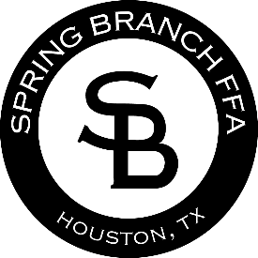
SBFFA Ambassador Handbook Acknowledgement Form

We have read the Spring Branch FFA Chapter Ambassador Handbook and understand the requirements for becoming an ambassador of the Spring Branch FFA Chapter.
I ______________________________, hereby approve of my
(Parent/Guardian Print Name)
son/daughter, running/becoming a Spring Branch FFA Ambassador for the next school year. I realize that he/she is responsible for his/her duties and upholding them. I further understand that my student is required to be at all scheduled mandatory events as listed in the handbook. I am aware that two or more unexcused absences or five demerits will result in my student’s early dismissal from the ambassador team.
I ______________________________, understand I am responsible
(Student Print Name)
for my duties as a chapter ambassador and will uphold them. I further understand that I am required to be at all scheduled mandatory events as listed in the student handbook. I am aware that two or more unexcused absences or five demerits will result in by being dismissed from the ambassador team early.

______________________ _________________
Student Signature Date
_______________________ _________________
Parent Signature Date

Complete and return this acknowledgement form and all other parts of the application to an FFA Advisor on or before the application due date.

Ambassador Application
The SBFFA student Ambassador team will be a small group of individuals comprised of Junior and Senior SBFFA members who will work closely with ASTs, campus counselors and potential FFA members to increase program awareness and opportunities among the AG science pathway and its coinciding CTSO. They are charged with and challenged to develop innovative approaches to promoting Ag Science and SBFFA in and around the district. Student Ambassadors will develop and deliver presentations that promote CTE, Ag Science classes and the FFA Organization to middle schools, high school, counselors, and any potential person who can take a vested interest in our program.

Program Benefits:
Students selected to serve as an SBFFA Ambassador will have the opportunity to develop their personal soft skills, influence the direction of SBFFA, and build lasting relationships with peers while networking and promoting your own abilities. SBFFA Ambassadors will be able to claim this role on their scholarship applications and award applications as a leadership role.

Qualifications:
SBFFA Student Ambassadors will be juniors or seniors that have completed a minimum of 1 year of AG classes and FFA Membership. Applicants will be required to hold their Greenhand Degree while working towards their Chapter or Lonestar Degree. Participants must be enrolled in a full year of AG classes during their year of service. Ambassadors will be required to miss school to present presentations to middle schools, high schools, program fairs and other events. Because of this, qualified applicants will be able to successfully manage schoolwork while missing instruction and be ale to maintain good grades.

Chairman:
The highest scoring candidate will be selected as the Chairmen of the Ambassador team for that year. The role of this student is to act as the point of contact between campus counselors, ASTs and the rest of the team. The Chairmen will be responsible for recording visit schedules and which ambassadors have met their minimum visit requirements as well as other duties set forth by the ASTs.

*Applications will be reviewed and scored by a committee consisting of 1 SBISD Administrator, 1 AG Science Teacher not connected to SBFFA and 1 Community Leader not connected to SBFFA. The following criteria will be used to evaluate the application.

Spring Branch FFA Ambassador Application
You may type your answers or print this application to fill out.
Name:
Phone:
Email:
Home Campus:
Next Year Grade:
Length of FFA Membership:
Are you willing and able to serve as the chairman? Yes or No
Do/will you have your own mode of transportation? Yes or No
Are you bilingual? Yes or No. If yes, which language(s) can you speak?

Officer Candidate and Parent Acknowledgment

We hereby acknowledge that all information contained in this application is factual. We also understand all officer requirements and expectations.

I ______________ hereby take responsibility for those rules, obligations, and expectations. If I fail to perform as required, I understand my fate will be the termination of service.
_____________________________ _________________
Ambassador Candidate Signature Date:

As the parent of a 2023-2024 ambassador candidate, I _________________ understand the responsibility my student is taking on.
_____________________________ _________________
Parent Signature Date

Have you held an officer position with the FFA:
Please list positions if applicable if none please leave blank. You are welcome to add more rows if needed.
Position | Chapter or District | School Year Served

List the courses taken in the Spring Branch Agriculture Science Program.
You are welcome to add more rows if needed.
Class Name | School Year & Semester

List any Supervised Agricultural Experience Projects in which you have participated in. (EX. Market Swine, Entrepreneurship in Landscaping, Working at a Feed Store)
You are welcome to add more rows if needed.
SAE Project | Year/Years

List the activities you have competed in or are/were involved in with the Spring Branch FFA. (EX. Livestock Judging, Leadership camps, Committees)
You are welcome to add more rows if needed.
Camp/Conference/Committee/LDE/CDE/SDE | Years of participation

List other (Non-FFA) clubs/organizations you are or have been a member of, the number of years you have participated, and any office you have held and/or any committees you serve on as well as your duties.
You are welcome to add more rows if needed.
Club/Organization | Years of participation | Committee/Office | Duties

Application Question Instructions: Type your answer to the below questions in the provided text box. Use as much space as needed to fully answer each question.
Application Questions:
- Why do you want to be an SBFFA Student Ambassador and what makes you a good candidate to serve in this role?

- What is one idea you have for increasing awareness of FFA and AG Classes at home campuses and in the middle schools?

- What does it mean to have a diverse FFA chapter and why is diversity among our members important?

- How would you measure the success of the ambassador team at the end of your year of service?

- Explain the steps needed to communicate when you do not know the answer to a question being asked of you on a school visit?

- A student is asking you about a certain pathway or career choice that you do not have much knowledge on. What would your response be to this student if they were asking you this question on a school visit?

